Create a Static Website on S3  
CS 470 Full Stack Development II.

Sergio Mateos

Southern New Hampshire University

1. Preparing the Angular Code
   1. Text

      Description automatically generatedng build --prod --base-href .
2. Creating an S3 Bucket
   1. 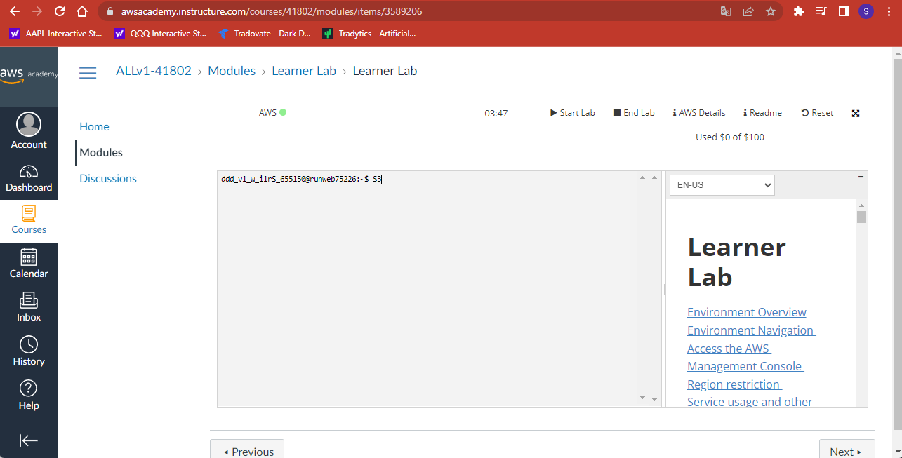AWS Console
   2. Graphical user interface, website

      Description automatically generatedAWS Management Console/ Creating a Bucket
   3. Graphical user interface, text

      Description automatically generatedCreate a Bucket
3. Deploying your website
   1. 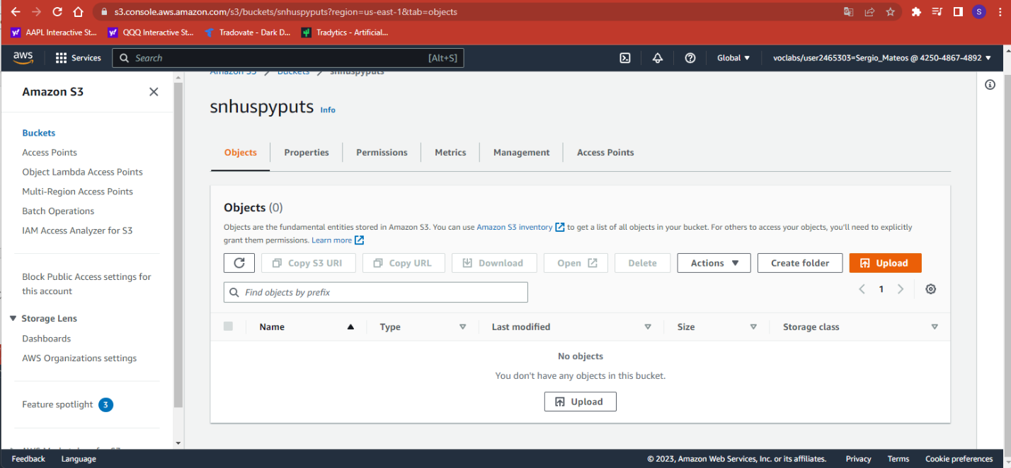Uploads files
   2. 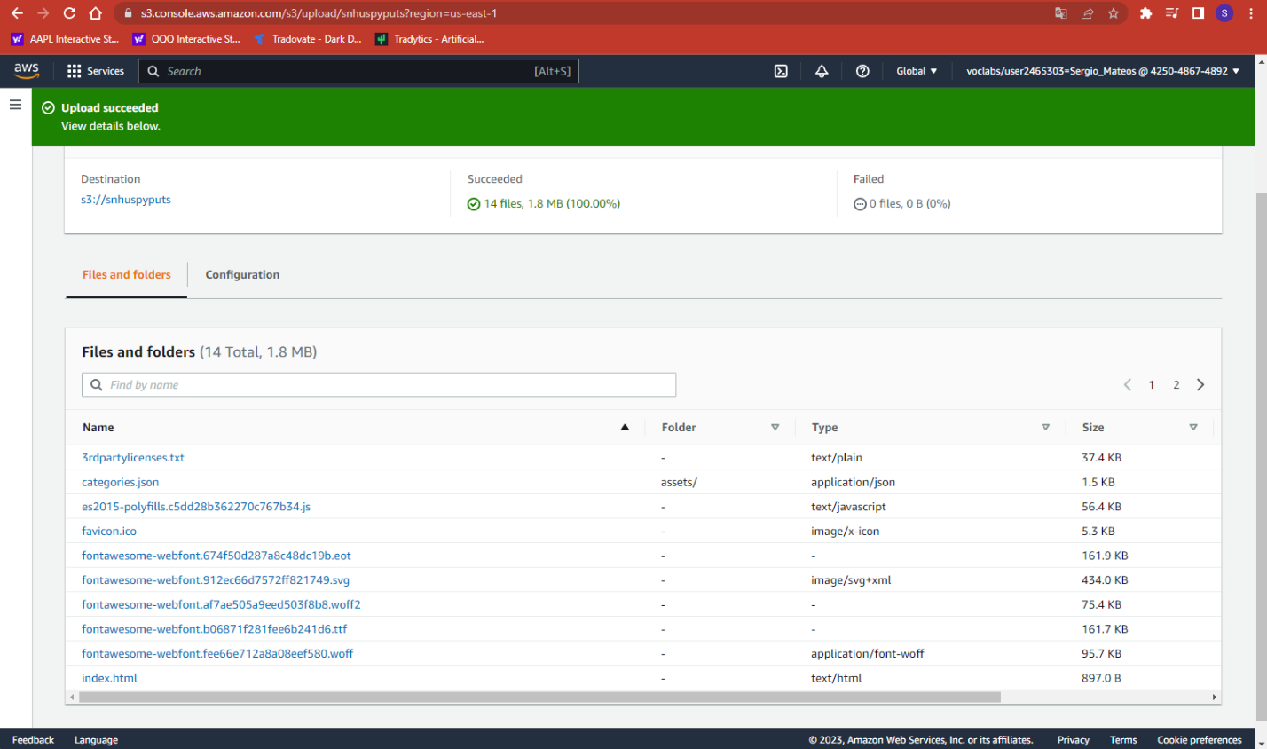Uploaded files
4. Configuring your S3 Bucket as a Website
   1. Graphical user interface, text, application

      Description automatically generatedProperties
   2. 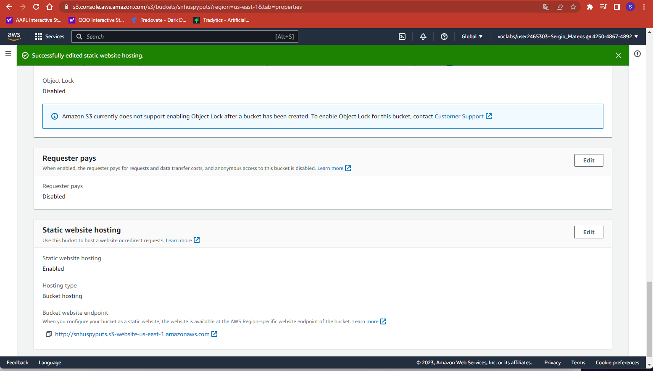Static website hosting dialog that shows S3 configured as a server.
5. Configuring Security for your S3 Bucket Website
   1. 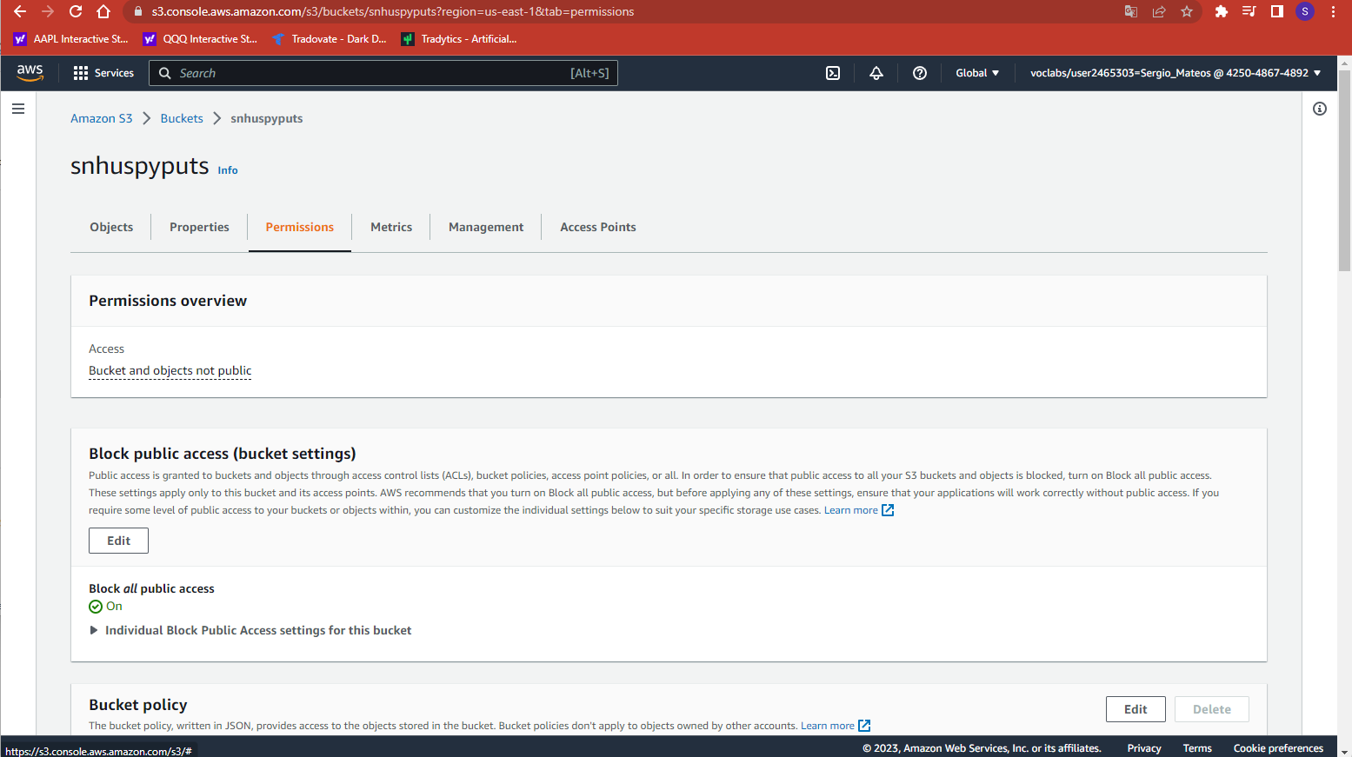Permission
   2. Making your Bucket Public

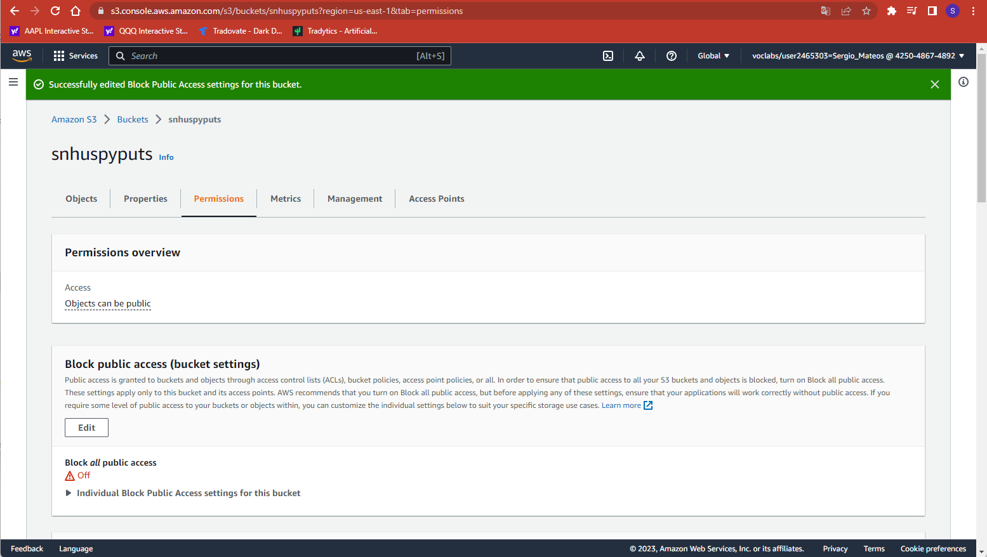

* 1. Graphical user interface, text, application

     Description automatically generatedEnabling the Read Access Operations
  2. Congrats!

[http://snhuspyputs.s3-website-us-east-1.amazonaws.com](http://snhuspyputs.s3-website-us-east-1.amazonaws.com/)